Inclusion of Other in the Self (IOS) Scale

This survey accompanies a measure in the SPARQTools.org Measuring Mobility toolkit, which provides practitioners curated instruments for assessing mobility from poverty and tools for selecting the most appropriate measures for their programs.To get a copy of this document in your preferred format, go to "File" and then "Download as" in the toolbar menu.

Age: Child, Teen, Adult
Duration: < 3 minutes
Reading Level: 9th to 12th grade
Number of items: 1
Answer Format: Circle a diagram

Scoring: Respondents choose a pair of circles from seven with different degrees of overlap. 1 = no overlap; 2 = little overlap; 3 = some overlap; 4 = equal overlap; 5 = strong overlap; 6 = very strong overlap; 7 = most overlap. The number chosen is the respondent’s score.

Sources:
Aron, A., Aron, E. N., & Smollan, D. (1992). Inclusion of other in the self scale and the structure of interpersonal closeness. Journal of Personality and Social Psychology, 63(4), 596-612.

Instructions: Please circle the picture below that best describes your relationship.

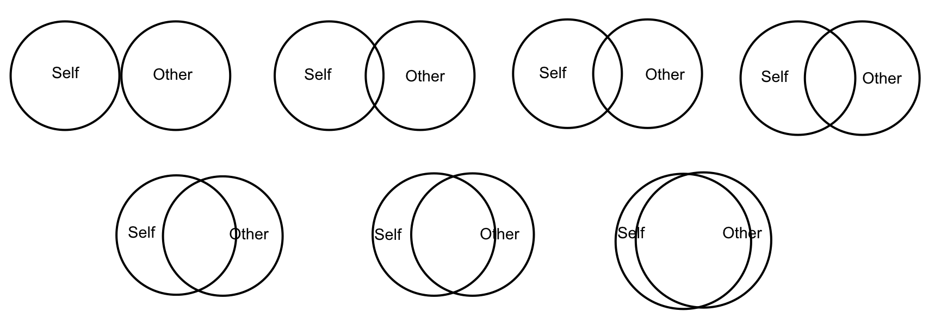

Instructions: Please circle the picture below that best describes your relationship.

